PHYSICS 20
UNIT 2: DYNAMICS
Chapter 3: Forces Can Change Velocity
  - Inquiry Lab: Relating Acceleration and Net Force

Max group size is 3 people.

Background Information:
Force of gravity is the mass times the acceleration due to gravity
F = mg (g = 9.81m/s²⁾
Average time: T_{ave} = (t₁ + t₂ + t₃) /3
Acceleration: d = v_{i}t + at²/2; v_{i} = 0
Rearranging: a = 2d / t²_{ave}

Newton’s 2nd law: a = F/m

Procedure

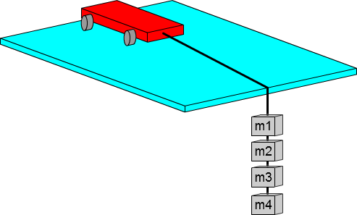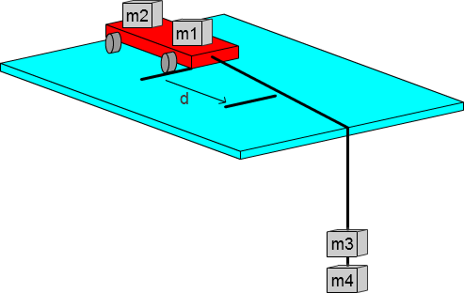
Step 3 - Initial set up
Step 7 – Move masses onto the cart from the string and repeat

- Measure and record the mass of each of the 4 masses.
- Set up the tape pieces, the masses, string and cart. Make sure that the masses don’t hit the ground before the cart passes the 2nd piece of tape.
- Measure and record the distance between the pieces of tape.
- Release the cart and simultaneously start the timer, stop the timer when the cart reaches the second piece of tape, and record the time.
- Repeat several times (3 trials)
- Repeat steps 5 and 6 but move a mass from the cart to the end of the string.
- Move another mass onto the cart and repeat steps 5 and 6 until there are no more masses on the string.

Observations

Distance between tape ____ (m)

Hanging  Mass  (kg) | Force of gravity  (N) | Net Force (N) | Time (s) |  |  | Average  Time (s) | Acceleration  (m/s²)  a=2d/t²
Hanging  Mass  (kg) | Force of gravity  (N) | Net Force (N) | Trial 1 | Trial 2 | Trial 3 | Average  Time (s) | Acceleration  (m/s²)  a=2d/t²

Analysis
- Calculate the force of gravity for each trial in the table. Show a sample calculation below:

- Why were the extra masses kept on the cart for the trials?

- Calculate the average time for each trial.
- Calculate the average acceleration for each trial in the table. Show a sample calculation below:

- Plot the acceleration as a function of the force graph.

- What is the value of the slope and what does it represent (include units)?

- What is the value of the x axis intercept from your graph?

- What does the x axis intercept from your graph represent? (Why doesn’t the mass accelerate even though a force is trying to accelerate the mass?)

- Subtract the x intercept from each force to get the net forces in the table and plot a graph of the magnitude of the acceleration as a function of the net force. This graph should now be really close to going through the origin.

- What type of mathematical relationship does the graph show (see your notes from the first day: proportional, positive linear, negative linear, parabolic, inverse or inverse square; and how can you tell?

- Does your experiment demonstrate Newton’s second law, and explain how you know from the graph.

- Hidden bonus question: (What did you want to measure but couldn’t?)

